|  |  |
| --- | --- |
| ProjectName | Smartfarmer-IOTEnabledsmartfarming  application |

ANACCOUNTWASCREATEDINMITAPPINVENTORANDFEATURESWEREOVERVIEWED

DESIGNER

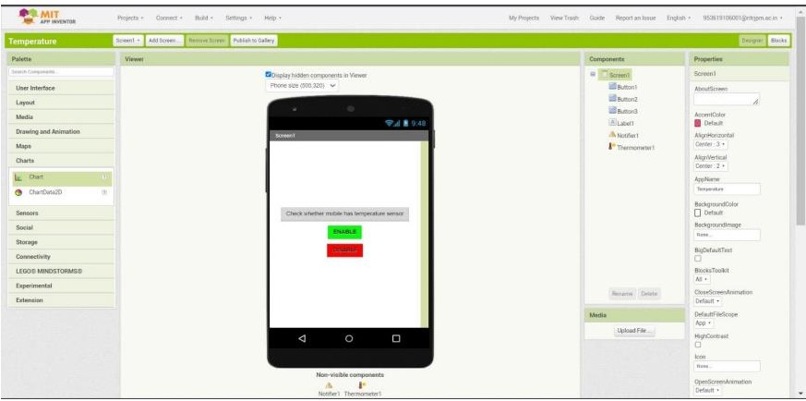

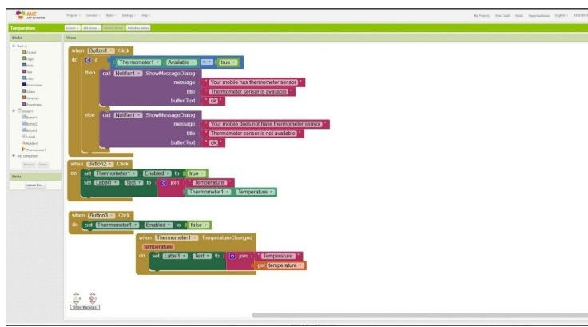BLOCK